A Project Report On

Energy Generation Through Rainfall

SUBMITTED IN PARTIAL FULFILLMENT OF THE REQUIREMENTS FOR
THE AWARD OF DEGREE OF BACHELOR OF ENGINEERING

IN
ELECTRONICS & COMMUNICATION ENGINEERING
BY

K. Manish (1608-23-735-089)

K. Swetha (1608-23-735-090)

J. Rohini (1608-23-735-310)

Under the guidance of

Mrs. Shilpa B. Darvesh
M.Tech (Ph.D)
Assistant Professor


Department of Electronics and Communication Engineering (NBA Accredited)

MATRUSRI ENGINEERING COLLEGE

(Sponsored by Matrusri Education society, Estd1980)

(Approved by AICTE, Affiliated to Osmania University) #16-1-486, Saidabad, Hyderabad, Telangana-500 059 www.matrusri.edu.in
2025-2026


Matrusri Engineering College

(An Autonomous Institution)
(Sponsored by: MATRUSRI EDUCATION SOCIETY, Estd:1980)
(Approved by AICTE, Affiliated to Osmania University)
email: principal@matrusri.edu.in web site: www.matrusri.edu.in
DEPARTMENT OF ELECTRONICS AND COMMUNICATION ENGINEERING
Date: 20-03-2025

Certificate

This is to certify that the project report entitled “ENERGY GENERATION THROUGH RAINFALL” being submitted by K.Manish, K.Swetha, J.Rohini in partial fulfillment for the award of the Degree of Bachelor of Engineering in Electronics and Communication Engineering of the Osmania University, Hyderabad, during 2025-26, is a record of bonafide work carried out under our guidance and supervision. The results presented in this project report have not been submitted to any other University or Institute for the award of any Degree or Diploma.

Project Coordinators:

Mr. A. Abhishek Reddy
Assistant Professor

Mr. M Thirupathi
Assistant Professor

Project Guide:

Mrs. Shilpa B. Darvesh
Assistant Professor

Dr. N. Srinivasa Rao
HOD-ECE

DECLARATION

This is to declare that the work submitted in the present project work report titled “ENERGY GENERATION THROUGH RAINFALL” is a record of bonafide work done by me in the Department of Electronics & Communication Engineering, Matrusri Engineering College, Saidabad, Hyderabad.

No part of the report is copied from books, journals, internet and wherever the subject content is taken; the same has been duly referred to in the text. The report generated is based on the project work carried out entirely by us and not copied from any other source.

K.Manish (1608-23-735-089)
K.Swetha (1608-23-735-090)
J.Rohini (1608-23-735-310)

Place: Hyderabad,
Date: 20-03-2025

ACKNOWLEDGEMENT

We would like to take this opportunity to place it on the record, that this project would never have taken shape but for the cooperation extended to us by certain individuals. Though it is not possible to name all of them, it would be a pardon on our part if we don’t mention some of the very important persons. Sincerely we acknowledge our deep sense of gratitude to the project guide, Mrs. Shilpa B. Darvesh Assistant Professor for her constant encouragement, help and valuable suggestions. We wish to thank her for her constant motivation and help throughout the project.
We would like to express our deep gratitude to the Head of Department Dr. N SRINIVASA RAO and Project Coordinators MR. M THIRUPATHI and MR. A ABHISHEK REDDY for their timely cooperation while carrying out the project. It is their friendliness that made me feel free and learn more from them.
Last but not the least we would like to thank all those people associated directly or indirectly with the project.

K.Manish (1608-23-735-089)
K.Swetha (1608-23-735-090)
J.Rohini (1608-23-735-310)

ABSTRACT

The global energy crisis and the pressing need for sustainable energy alternatives have spurred innovation in the field of renewable energy harvesting. This paper investigates a novel approach to generate power by harnessing the kinetic energy of falling raindrops using the piezoelectric effect. Piezoelectric materials are capable of converting mechanical stress directly into an electrical charge, which makes them a key component for recovering vibrational energy from ambient sources like rain. In this system, specialized piezoelectric transducer plates are arranged on a collector panel (e.g., a rooftop) where the impact of raindrops creates a mechanical force, generating an alternating current (AC) voltage.
The output voltage from the sensor array is then converted to direct current (DC) using a rectifier circuit for efficient storage in batteries. Experimental investigations and prototypes have demonstrated that this method can successfully generate small but usable amounts of power, suitable for low-power electronic devices, and offers a valuable, complementary power source during poor weather conditions when solar efficiency is low. This technology shows significant potential for scalability and integration into smart city infrastructure for localized, clean power generation.

Keywords: Piezoelectric Effect, Energy Harvesting, Raindrop Generator, Kinetic Energy, Sustainable Power, Emergency Power.

CONTENTS

 | Page no.
Certificate | i
Declaration | ii
Acknowledgement | iii
Abstract | iv
List Of Figures | vii
List Of Tables | vii

Chapter 1. INTRODUCTION
1.1 Introduction | 1
1.2 Problem Specifications | 1
1.3 Project Goal | 2
1.4 Objectives | 2
1.5 Methodology | 3

Chapter 2. LITERATURE SURVEY | 5
Chapter 3. BLOCK DIAGRAM AND SCHEMATIC DIAGRAM
3.1 Block Diagram | 13
3.2 Working | 13
3.3 Schematic Diagram | 15

Chapter 4. HARDWARE COMPONENTS
4.1 Piezoelectric Transducer | 16
4.2 Lithium ion Battery | 16
4.3 Voltage Booster Module | 17
4.4 Mini Voltage Meter | 19
4.5 DC to AC Converter | 20

4.6 LED Bulb | 21
4.7 DC Water Pump | 21

Chapter 5. RESULT
5.1 Basic Functionality and Signal Verification | 23
5.2 Power Output Measurement | 25
5.3 Energy Storage and Practical Application | 25
Conclusion | 26
Chapter 6. CONCLUSION
6.1 Conclusion | 27
6.2 Future Scope | 27
REFERENCES | 29

LIST OF FIGURES

S.No. | Figure no. | Figure Description Page no.
1 | Fig 1.2 | PROJECT MODEL | 2
2 | Fig 3.1 | BLOCK DIAGRAM | 13
3 | Fig 3.3 | SCHEMATIC DIAGRAM | 15
4 | Fig 4.1 | PIEZOELECTRIC TRANSDUCER | 16
5 | Fig 4.2 | LITHIUM ION BATTERY | 17
6 | Fig 4.3 | VOLTAGE BOOSTER MODULE | 18
7 | Fig 4.4 | MINI DC VOLTAGE METER | 19
8 | Fig 4.5 | DC TO AC CONVERTER | 20
9 | Fig 4.6 | LED BULB | 21
10 | Fig 4.7 | DC WATER PUMP | 22
11 | Fig 5.0 | COMPLETE PROJECT | 23
12 | Fig 5.1.1 | CONNECTIONS | 24
13 | Fig 5.1.2 | FULL WAVE BRIDGE RECTIFIER | 24
14 | Fig 5.2 | VOLTAGE MEASUREMENT | 25
15 | Fig 5.3 | PROJECT OUTPUT | 26

LIST OF TABLES

S.No. | Table no. | Table Description | Page no.
1 | Table 5.1 | GENERATED ENERGY CALCULATIONS | 26

CHAPTER 1
INTRODUCTION

Introduction :
The increasing global demand for energy, combined with the rapid depletion of fossil fuels, has intensified the search for sustainable and eco-friendly power generation methods. Renewable energy technologies such as solar, wind, and hydropower have made significant contributions toward reducing environmental impact, yet each comes with limitations particularly under unfavorable weather conditions. For instance, solar panels experience a sharp decline in efficiency during cloudy or rainy periods, leaving a gap in consistent power availability.
To address this challenge, researchers have begun exploring unconventional sources of ambient energy that remain largely untapped. One such promising avenue is the harvesting of energy from falling raindrops. Raindrop impact carries kinetic energy that is typically wasted, but with the use of piezoelectric materials substances capable of converting mechanical stress into electrical charge this energy can be effectively captured and utilized.
Energy generation through rain using piezoelectric systems presents a unique opportunity to supplement traditional renewable sources. By integrating piezoelectric transducer plates onto surfaces such as rooftops or outdoor panels, the mechanical force exerted by raindrop impacts can be converted into electrical energy. This harvested energy, though modest in magnitude, can be rectified and stored for powering low-consumption electronic devices, offering a reliable source of clean energy during rainy or low-sunlight conditions.
Given its minimal environmental footprint, compatibility with existing infrastructure, and potential for scalability, the concept of rain-based energy harvesting stands as an innovative step toward a more resilient and diversified renewable energy ecosystem. This paper explores the working principles, system design, experimental findings, and future possibilities of generating energy from rain using the piezoelectric effect.

Problem Specifications :

The increasing global reliance on electrical power, coupled with the escalating frequency and intensity of severe weather events, highlights a critical vulnerability in conventional energy infrastructure. During periods of continuous, heavy rainfall, power outages often occur, rendering traditional electricity sources inaccessible and leaving homes and critical services without power for extended durations. Furthermore, existing renewable energy solutions, such as solar photovoltaics (PV), become severely limited during these prolonged poor weather conditions, creating a significant energy generation gap precisely when reliability is most needed for emergency response and sustained essential household operations. The problem is the lack of a reliable, localized, and complementary power source that can effectively harvest energy during periods of intense rainfall and grid failure. This project addresses this vulnerability by proposing a novel system to convert the ubiquitous kinetic energy of falling raindrops into usable electricity.

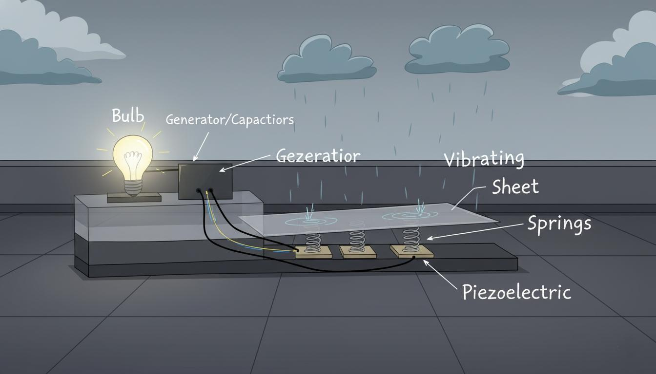
Fig 1.2 Project Model

Project Goal :

This research aims to design, develop, and validate a piezoelectric-based energy harvesting system capable of generating supplementary electrical power during heavy rainfall events, thus providing a critical source of emergency power for low-wattage household appliances and communication devices when the main power grid is down.

Objectives :
- To design a system that harvests electrical energy from the kinetic energy of falling raindrops using piezoelectric materials.
- To study the piezoelectric effect and evaluate how raindrop impact generates electrical charge.
- To select and test suitable piezoelectric materials for maximum output.
- To develop a prototype with piezoelectric transducers.
- To design a rectifier and storage circuit for converting AC output to usable DC energy.
- To measure the voltage, current, and power generated under different rainfall intensities.
- To analyze how droplet size, impact force, and arrangement of sensors affect output efficiency.
- To determine the feasibility of using this system to power low-energy devices.
- To explore the potential for integrating the rain-energy system with existing renewable systems like solar panels.
- To identify limitations and propose improvements for future development and scalability.

Methodology :
The methodology for this project was developed to systematically design, construct, and evaluate the performance of a piezoelectric system for converting the kinetic energy of raindrops into usable electrical energy.

1.5.1 System Design and Component Selection
The system is fundamentally an energy harvesting circuit coupled with a mechanical energy collector.
- Transducer Selection: PZT (Lead Zirconate Titanate) ceramic discs were selected as the active material due to their high electromechanical coupling factor and mechanical robustness. The discs were chosen to operate in the d31 mode (where the strain is perpendicular to the electric field), which is ideal for converting bending or impact forces into electrical charge.
- Collector Panel and Array: A thin, flexible substrate (e.g., acrylic or PCB) served as the collector panel. The PZT elements were strategically adhered to the underside of this panel in a series-parallel array configuration. The series connection was prioritized to boost the intrinsically low voltage generated by individual drops, while the parallel connection ensured a sufficient current output for subsequent charging.
- Power Management Circuit (PMC): Given that the piezoelectric element produces an Alternating Current (AC) impulse, a PMC was essential. This circuit features a Full-Wave Bridge Rectifier (using Schottky diodes for minimal forward voltage drop) to convert the AC signal to DC, followed by a large smoothing capacitor (e.g., electrolytic capacitor) to filter out ripple and provide a stable DC voltage for charging.
- Energy Storage: The rectified DC output was connected to a low-capacity, rechargeable battery (e.g., a small Li-ion or NiMH cell) via a unidirectional diode to prevent reverse current flow and serve as the final sink for the harvested energy.

1.5.2. Experimental Setup and Construction
The physical setup was designed to isolate the system for controlled testing and integrate the electrical components.
- Mechanical Assembly: The piezoelectric discs were secured to the collector panel to form a continuous, impact-sensitive surface. The entire panel assembly was mounted within a rigid frame, ensuring the PZT elements were only subjected to the downward impact force.
- Circuit Integration: The output leads from the PZT array were connected directly to the input terminals of the Full-Wave Bridge Rectifier. The rectifier output was then connected across the smoothing capacitor, which in turn was connected to a dedicated load or the rechargeable battery through a protection diode.
- Rainfall Simulation: To ensure the reproducibility and control necessary for accurate performance testing, a custom-built rainfall simulation apparatus was constructed. The system utilized an empty plastic storage container positioned directly above the piezoelectric collector panel. The bottom of this container was intentionally perforated with small, uniformly spaced holes to serve as a constant-rate showerhead, mimicking the distribution of natural rain. The water supply for the simulation was provided by a separate reservoir (another container) integrated with a submersible water pump. The pump fed water through a pipe, which was routed up and into the perforated plastic container.

CHAPTER 2

LITERATURE SURVEY

[1] Evaluation of the energy generation potential of rain cells Author links open overlay
panelL.E. Helseth H.Z. Wen (L.E. Helseth, H.Z. Wen)

Abstract:
Raindrops carry mechanical energy which with proper transducers can be converted into electrical energy. Several promising transducer technologies have been developed and tested in the laboratory, but it is also necessary to incorporate the characteristics of real rain in order to be able to assess the energy generation potential of such technologies. In this paper, we present a new model for predicting the electrical output of a rain cell exposed to real rainfall parameters. We review the important parameters characterizing rain, and identify how they contribute to the available kinetic energy of a rain shower. Most significant is the rainfall intensity, which together with the physical characteristics of the transducer governs the electrical output energy of the rain cell. Here we show that under the simplifying conditions of no wind and realistic rainfall intensity distribution, the electrical output energy can be predicted based on meteorological data combined with knowledge of the characteristics of the specific rain cell under study. Future planning of the impact of rain cells on the renewable energy market requires knowledge of potential locations and performance, thus suggesting the need for such a model.

Conclusion:
We have reviewed the concept of rain cells, and discussed how real rainfall parameters influence this type of energy conversion system. A new model is presented, which allows one to predict the electrical energy output of rain cells based on meteorological data. Although future breakthroughs in materials technology might improve the efficiency of the transducer mechanisms, the rainfall parameters reviewed here should be considered in future designs of energy harvesting systems.

[2] Harvest rain energy by polyaniline-graphene composite films (Y Wang, J Duan,
Y Zhao, B He, Q Tang - Renewable Energy, 2018 - Elsevier)

Abstract:
Rain energy harvest by a cost-effective technique is promising to increase renewable energy production. In this work, we demonstrate experimental realization of a category of film-type converter tailored with polyaniline (PANi) or PANi-graphene complex films to harvest rain energy. According to the charging/discharging processes of cation/electron pseudo-capacitances at rain/film interfaces, these converters produce maximized current and voltage of 3.80 μA/droplet and 85.01 μV/droplet, respectively. The resultant electricity outputs can be further enhanced by enriching electron concentration at the surfaces of these materials. Furthermore, these rain-enabled converters have good long-term stability under persistent stimulus by raindrops. This work may provide new opportunities of harvesting waste renewable energies from nature.

Conclusion:
In summary, film-type rain-enabled converters tailored with PANi and further PANi-graphene complex have made significant contributions in electricity generation. Attributing to the charging/discharging EDL pseudocapacitances at rainwater/film interface, the electricity outputs are yielded from ten to thousands of micron levels. In this fashion, high electron concentration arising from the enriched-electron surface of the PANi-graphene complex has successfully realized the improvement of harvest rain.

[3] Solar-Rains-Wind-Lightning Energy Source Power Generation System (PK
Bhattacharjee - International Journal of Computer)

Abstract:
This paper describes a new and evolving Electrical Power Generation System by integrating Solar Energy, Rains Energy, Wind Energy and Lightning Energy as non conventional energy sources. All the natural wastage energies are used for production of electricity. Thus, the Electrical Power or Electricity is available with a minimum cost and pollution free to anywhere in the world at all times. This process reveals a unique step in electricity generation and availability from natural resources without hampering the ecological balance. We can have an uninterrupted power supply irrespective of the natural condition without any sort of environmental pollution. Moreover this process yields the least production cost for electricity generation. Utilization of lightning energy for generation of electricity reveals a new step. It will bring a pollution and accident free homogeneous nature to safeguard the world in a unique way.
Index Terms Hydro electricity power plant, Lightning power generation system, Non conventional energy sources, Nuclear power generation plant, Rains power generation system, Solar power generation system, Solar-Rains-WindLightning Energy- Integrating Power Generation System, Thermal power generation plant, Wind power generation system.

Conclusion:
This Integrating Solar-Rains-Wind-Lightning Energy Power Generation System will be highly effective in all places, especially in rural areas where the commercial electricity has not reached or undelivered. It causes no effect on nature i.e. pollution free, at the same time not prone to any kind of accident due to lightning and highly suitable for domestic purposes. It is also useful to urban and city areas, simultaneously with the commercial power supply to minimize power supply load i.e. cut short power charge. By using this system, people can save electricity charge and very less maintenance charge to this equipment is required. The designing of this equipment is done in such a way that it is very compact and acts as user friendly.
When it is manufactured on a large scale, the cost of this integrated natural resources power generation system is affordable. Moreover there is no power failure or load shedding situation at any time. Therefore, it is the most reliable renewable power or electricity resource with the least expenditure in the globe.

[4] An all-weather solar cell that can harvest energy from sunlight and rain (Q Tang,
H Zhang, B He, P Yang - Nano Energy, 2016 - Elsevier)

Abstract:
Future solar cells may produce electricity in all weathers. We present here a cost-effective and high-efficiency graphene based conducting composite tailored all-weather solar cell that can be actuated with raindrops and sunlight. Due to the formation of π-electron|cation double-layer pseudocapacitance at conducting composite/raindrop interface, the delocalized π-electrons on graphene can migrate along percolating pathways forward at spreading process and backward at shrinking periods, resulting in charging and discharging of the pseudocapacitor. The optimized solar cell yields a photoelectric conversion efficiency of 9.8% under simulated sunlight irradiation (air mass 1.5, 100 mW cm−2) as well as current over several microamps and voltage of hundreds of microvolts under simulated raindrops. This work could extend our knowledge of future all-weather solar cells.

Conclusion:
In summary, an all-weather solar cell is fabricated by integrating G-CB/PTFE conducting composite with a solar cell for energy harvesting from sun and rain. This solar cell yields a photoelectric conversion efficiency of 9.80% under AM1.5 sun irradiation. Due to the formation of π-electron|cation pseudocapacitance at G-CB/PTFE/raindrop interface, periodic current and voltage signals can be produced by dropping simulated rain droplets on G-CB/PTFE conducting composite electrode.

[5] Energy intensity of rainwater harvesting systems (AS Vieira, CD Beal, E Ghisi, RA
Stewart - … and Sustainable Energy Reviews, 2014 - Elsevier)

Abstract:
Rainwater Harvesting Systems (RHS) are increasingly used in buildings to mitigate water shortage and rising prices of centralised water supply. Notwithstanding the benefits of RHS, they may also promote adverse impacts mainly related to the high consumption of energy. In this context, energy intensity (i.e. unit of energy per unit of water) is a crucial parameter for assessing the environmental feasibility of different RHS. However, only recently has attention been drawn to the connection between water and energy consumption, which has been prompted by the increasing importance of water security, energy efficiency and economic feasibility. This connection, known as the water-energy nexus, has been increasingly acknowledged as a key principal for water planning.

Conclusion:
The median energy intensity of the entire sample of reviewed theoretical and empirical RHS studies was 0.20 and 1.40 kWh/m3, respectively. Empirical studies provide strong evidence that currently implemented RHS often have operational energy intensities that are far higher than centralised town water systems and are similar to recycled water supply systems. On the other hand, as outlined in theoretical studies, emerging configurations for RHS based on gravity rainwater supply with the use of rainwater.

[6] Techno-economic analysis of a wind–solar hybrid renewable energy system with
rainwater collection feature for urban high-rise application (W.T. Chong,
M.S.Naghavi, S.C. Poh, T.M.I. Mahlia, K.C. Pan)

Abstract:
The technical and economic feasibility study of an innovative wind–solar hybrid renewable energy generation system with rainwater collection feature for electrical energy generation is presented in this paper. The power generated would supply part of the energy requirements of the high-rise building where the system is installed. The system integrates and optimizes several green technologies; including urban wind turbines, solar cell modules and rain water collectors. The design was conceptualized based on the experiences acquired during the development and testing of a suitable wind turbine for Malaysian applications. It is compact and can be built on top of high-rise buildings in order to provide on-site renewable power to the building. It overcomes the inferior aspect of the low wind speed by channeling and increasing the speed of the high altitude free-stream wind through the power-augmentation-guide-vane (PAGV) before it enters the wind turbine at the center portion. The shape or appearance of the PAGV that surrounds the wind turbine can be blended into the building architecture without negative visual impact (becomes part of the building). The design improves the starting behavior of wind turbines. It is also safer for people around and reduces noise pollution. The techno-economic analysis is carried out by applying the life cycle cost (LCC) method. The LCC method takes into consideration the complete range of costs and makes cash flows time-equivalent. The evaluations show that for a system with the PAGV (30 m diameter and 14 m high) and an H-rotor vertical axis wind turbine (17 m diameter and 9 m high) mounted on the top of a 220 m high building, the estimated annual energy savings is 195.2 MW h/year.

Conclusion:
In this paper, a techno-economic analysis has been carried out on an innovative wind–solar hybrid renewable energy generation system with rainwater collection feature for urban high-rise application. Technical viability of the system shows that by integrating the available technologies of wind turbine, PV panels and rainwater collector with the PAGV, this system can cover a significant portion of a building’s energy demands and helps to make the building independent.

[7] Silicon-based hybrid cell for harvesting solar energy and raindrop electrostatic
energy (L Zheng, ZH Lin, G Cheng, W Wu, X Wen, S Lee… - Nano Energy, 2014 -
Elsevier)

Abstract:
Silicon-based solar cells are by far the most established solar cell technology. The surface of a Si solar cell is usually covered by a layer of transparent material to protect the device from environmental damages/corrosions. Here, we replaced this protection layer by a transparent triboelectric nanogenerator (TENG), for simultaneously or individually harvesting solar and raindrop energy when either or both of them are available in our living environment. The TENG is made of a specially processed polytetrafluoroethylene (PTFE) film, an indium tin oxide (ITO) and a polyethylene terephthalate (PET) layer. Under solar light irradiation (12 W/m2) on a rainy day, the fabricated high-efficiency solar cell provides an open-circuit (Voc) of 0.43 V and short-circuit current density (Jsc) of 4.2 A/m2. And the TENG designed for collection of raindrop energy gives an AC Voc of 30 V and Jsc of 4.2 mA/m2 when impacted by water drops at a dripping rate of 0.116 ml/s. In rainy days, the performance of solar cells decreases greatly, while TENG can be a good compensation for green energy harvesting. From these results, we can see that the hybrid cell formed by a solar cell and a water-drop TENG have great potential for simultaneously/individually harvesting both solar energy and raindrop electrostatic energy under different weather conditions, especially in the rainy season.

Conclusion:
In summary, we have developed a novel hybrid energy cell that consists of a specially processed Si-based solar cell and a special water-drop TENG, which can be used to simultaneously/individually harvest both solar and raindrop electrostatic energy. The bottom solar cell device was designed by using a Si micropyramid n+–p–p+ junction, which can provide an output voltage of 0.6 V and output current density of 350 A/m2 under a light intensity of 1000 W/m2. And the TENG designed for collection of raindrop.

[8] A droplet-based electricity generator for large-scale raindrop energy harvesting
(Z Li, D Yang, Z Zhang, S Lin, B Cao, L Wang, ZL Wang… - Nano Energy, 2022 -
Elsevier)

Abstract:
Droplet-based electricity generator (DEG) has been demonstrated as efficient method to harvest energy from the natural environment. However, the complex structure and low output power density are still two barriers to wide applications. To this end, by making full use of the self-capacitance effect of the upper electrode, a droplet-based electricity generator with a simple open structure (SCE-DEG) was proposed in this paper. The working principle of SCE-DEG and the effects of electrode geometry and droplet parameters (volume, conductivity, and dropping frequency) on its output voltage were analyzed. Compared with the DEG, the upper electrode of SCE-DEG does not need to connect to the lower electrode and the ultra-high instantaneous peak output power (765 W/m2) can still be achieved by self-capacitance effect of the upper electrode. This research provides a reference for the large-scale raindrop energy harvesting.

Conclusion:
In summary, this paper proposed a droplet-based SCE-DEG with a simple structure. Based on the self-capacitance of the upper electrode, the SCE-DEG could effectively harvest raindrop energy. The test results showed it could produce 212 mW output power by a 61 μL water droplet and can direct light up 100 commercial LEDs. As with a simple structure, high output power and good low-frequency energy harvesting characteristics, SCE-DEG might provide a practical scheme for the large-scale droplet.

[9] Boosting power conversion efficiency by hybrid triboelectric nanogenerator/silicon
tandem solar cell toward rain energy harvesting (L Zhao, J Duan, L Liu, J Wang,
Y Duan, L Vaillant-Roca… - Nano Energy, 2021 - Elsevier)

Abstract:
The weather-dependent and intermittent photoelectric conversion capacity of the traditional photovoltaics call for rational design on device architecture to realize persistent power output under multiple-energy-source stimuli. Herein, we demonstrate a novel triboelectric nanogenerator/silicon (TENG/Si) tandem hybrid solar cell by stacking top silver/polydimethylsiloxane sub-cell onto bottom monocrystalline Si solar cell for simultaneously harvesting solar and rain energies. Upon systematically optimizing the device configuration and the properties of top nanogenerator, the bottom Si solar cell is used as a friction layer to regulate the charge distribution of TENG, achieving a short-circuit current of 7.59 μA, a peak open-circuit voltage of 37.19 V under the stimuli of single raindrop and a power conversion efficiency enhancement by 20% in comparison with pristine Si solar cell. Finally, 26 blue light-emitting diodes can be lighted up by one raindrop. Given the compelling advantages of enhanced power output and expanded working time, this physical proof-of-concept TENG/Si tandem hybrid solar cell provides new opportunities to collect multiple energies from nature and to promote the development of weather-independent solar cells.

Conclusion:
In summary, we demonstrate a TENG/Si tandem hybrid solar cell by integrating Ag/PDMS electrode with a traditional monocrystalline Si solar cell to simultaneously harvest solar energy and rain energy. In comparison with the state-of-the-art hybrid solar panels, this work is highlighted by the exposed Ag electrode at PDMS surface to establish a two-electrode TENG by connecting top Ag and bottom Al electrodes. Arising from the interaction between two-electrode TENG and solar cell, such as the nanogenerator.

[10] Rain-Induced Vibration Energy Harvesting Using Nonlinear Plates with
Piezoelectric Integration and Power Management (YR Wang, WT Lin, BJ Huang -
Sensors, 2025)

Abstract:
Vibration energy offers promising potential for renewable energy harvesting, especially in conditions where conventional sources such as solar power may be limited or intermittent. This study proposes a rain energy harvester (REH) that converts the kinetic energy of raindrops into electrical energy using nonlinear thin plates, integrated with piezoelectric elements. Two plate configurations—fully hinged (H-H-H-H) and clamped–hinged–free–hinged (C-H-F-H)—are investigated. Theoretical modeling and simulation results are compared with experimental data, with special attention paid to the role of slapping forces in improving prediction accuracy. A power management system is also introduced to stabilize and regulate the harvested voltage. Results confirm the feasibility of rain-induced energy harvesting, showing potential for application in rain-prone areas and integration with existing infrastructure such as solar panels, tents, or canopies.

Conclusion:
This study presents a rain-induced vibration energy harvesting system (REH) using nonlinear thin plates with integrated piezoelectric elements. Two structural configurations were investigated: a fully hinged plate (H-H-H-H) and a clamped–hinged–free–hinged plate (C-H-F-H). The nonlinear plate behavior was modeled using Hamilton’s principle combined with classical Kirchhoff plate theory and von Kármán-type geometric nonlinearity. The governing equations were solved using the fourth-order Runge–Kutta method under random impact forces simulating raindrop excitation.
A key contribution of this study is the inclusion of slapping forces, representing localized raindrop impacts. Theoretical results that incorporate slapping forces show significantly improved agreement with experimental measurements, reducing the voltage prediction error from 67.7% to 3.88% for corner-mounted piezoelectric patches. In contrast, edge-mounted patches remain affected by dual boundary interactions, resulting in a residual error of approximately 32%, which is acknowledged as a modeling limitation beyond the current study’s scope.
Comparative analysis between theoretical simulations and ANSYS results further validates the nonlinear plate model under deterministic loading. While ANSYS effectively simulates structural deformation, its standard framework does not account for transient, stochastic slapping forces, highlighting the necessity of a customized theoretical approach.

CHAPTER 3
BLOCK DIAGRAM AND SCHEMATIC DIAGRAM

3.1 Block Diagram:
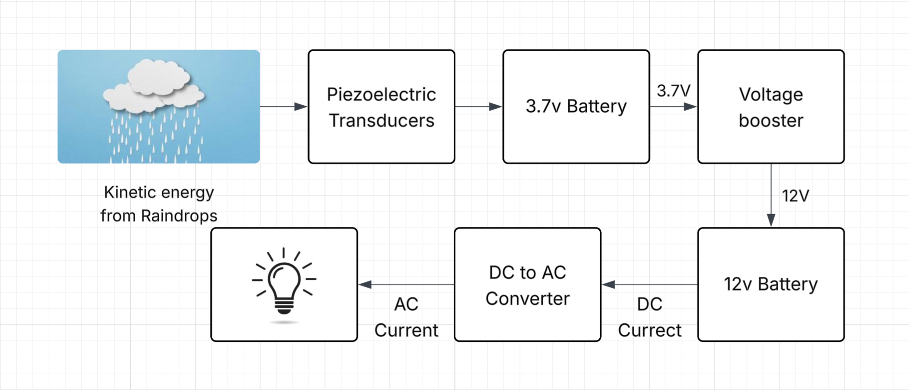

Fig 3.1 Block diagram

3.2 Working:
The operation of the raindrop energy harvesting system is based on the piezoelectric effect, which provides a direct mechanism for converting mechanical energy (from the raindrop's impact) into electrical energy. The process is divided into three functional stages: Mechanical Energy Input, Electromechanical Conversion, and Power Management.

1. Mechanical Energy Input (Raindrop Impact)
The operation begins when a raindrop, falling due to gravity, reaches its terminal velocity and strikes the surface of the collector panel.
- Kinetic Energy: The falling raindrop possesses kinetic energy, which is dependent on its mass and impact velocity.
- Mechanical Stress: Upon impact, this kinetic energy is rapidly transferred to the collector panel as a localized mechanical stress or force impulse.
- Strain Generation: The force of the impact causes the flexible collector panel to deform or bend. Because the PZT (piezoelectric) discs are rigidly attached to the underside of the panel, this bending action subjects the PZT material to significant mechanical strain (stress-induced deformation).

2. Electromechanical Conversion (The Piezoelectric Effect)
This is the core stage where energy is converted from mechanical to electrical form.
- Piezoelectric Principle: The PZT material, being a piezoelectric crystal, is polarized. When the material is subjected to mechanical strain, its internal crystalline structure is deformed. This deformation causes a displacement of the positive and negative charge centers within the material.
- Charge Generation: This charge separation results in the accumulation of surface charges on the electrodes attached to the PZT discs, generating a transient Alternating Current (AC) voltage impulse.
- Array Output: Since a single drop generates a very low voltage, the multiple PZT discs are connected in an array (series-parallel configuration). This arrangement aggregates the voltage from individual impacts and provides a combined, higher-amplitude AC signal for the next stage.

3. Power Management and Energy Storage
The raw AC signal from the array is unsuitable for direct storage and must be processed.
- Rectification: The generated AC signal is fed into a Full-Wave Bridge Rectifier circuit. This circuit converts the fluctuating AC voltage into a pulsating Direct Current (DC) voltage, ensuring the current always flows in one direction.
- Smoothing and Stabilization: The pulsating DC signal then passes through a large smoothing capacitor. This capacitor stores charge during the high peaks of the pulse and discharges during the low troughs, effectively reducing voltage ripple and providing a relatively stable DC output.
- Storage: The stabilized DC output is finally connected to a rechargeable battery. A protection diode (unidirectional) is placed before the battery to prevent the stored energy from flowing back into the power management circuit when the system is not actively generating power. This stored energy can then be used to power low-power electronic devices.
In summary, the system operates by transforming the instantaneous kinetic energy of a raindrop impact into mechanical strain, which is then instantaneously converted into an electrical charge by the piezoelectric material, and finally processed into stable DC power for useful storage.

3.3 Schematic Diagram:
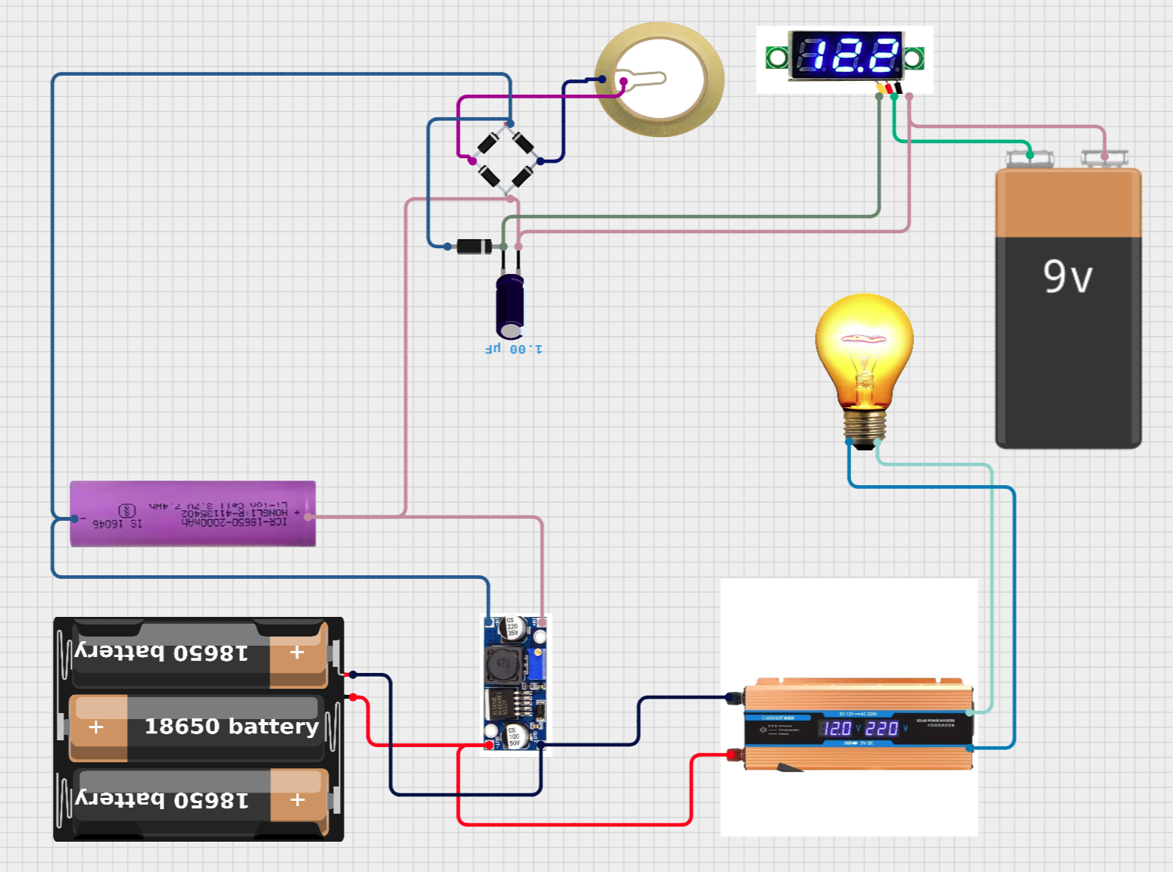
Fig 3.3 Schematic diagram

CHAPTER 4
HARDWARE COMPONENTES

The energy generation through rain hardware components, each playing a vital role in the overall functionality of the system. Below is a description of the primary components utilized in this project:

4.1 Piezoelectric Transducer
The piezoelectric effect results from the linear electromechanical interaction between the mechanical and electrical states in crystalline materials with no inversion symmetry. The piezoelectric effect is a reversible process: materials exhibiting the piezoelectric effect also exhibit the reverse piezoelectric effect, the internal generation of a mechanical strain resulting from an applied electric field. For example, lead zirconate titanate crystals will generate measurable piezoelectricity when their static structure is deformed by about 0.1% of the original dimension. Conversely, those same crystals will change about 0.1% of their static dimension when an external electric field is applied. The inverse piezoelectric effect is used in the production of ultrasound waves.
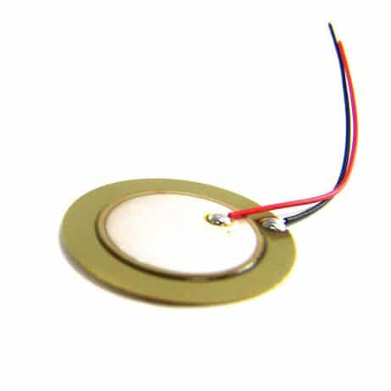
Fig 4.1 Piezoelectric Transducer

4.2 Lithium ion Battery

A lithium-ion battery, or Li-ion battery, is a type of rechargeable battery that uses the reversible intercalation of Li⁺ ions into electronically conducting solids to store energy. Li-ion batteries are characterized by higher specific energy, energy density, and energy efficiency and a longer cycle life and calendar life than other types of rechargeable batteries. Also noteworthy is a dramatic improvement in lithium-ion battery properties after their market introduction in 1991; over the following 30 years, their volumetric energy density increased threefold while their cost dropped tenfold.^{[8]} In late 2024 global demand passed 1 terawatt-hour per year,^{[9]} while production capacity was more than twice that.

Uses: Lithium-ion batteries are used in a multitude of applications, including consumer electronics, toys, power tools, and electric vehicles.More niche uses include backup power in telecommunications applications. Lithium-ion batteries are also frequently discussed as a potential option for grid energy storage, although as of 2020, they were not yet cost-competitive at scale. Some submarines have also been equipped with lithium-ion batteries.
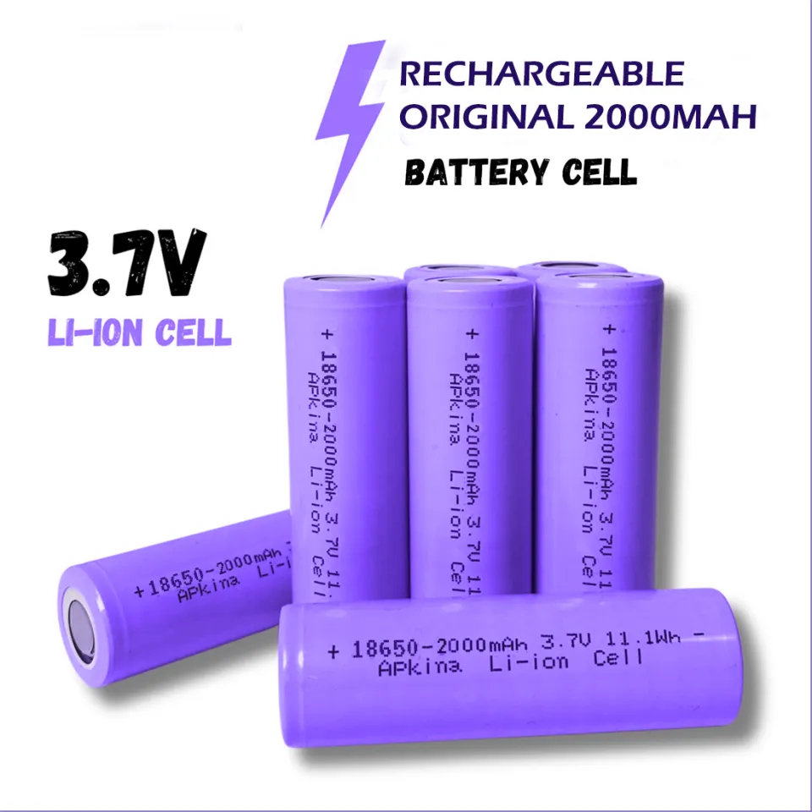
Fig 4.2 Li-ion Battery

4.3 Voltage Booster Module
A voltage booster module is an electronic power-conversion unit designed to increase a low DC input voltage to a higher, regulated DC output voltage. It is commonly referred to as a DC–DC boost converter and is widely used in battery-powered and low-voltage electronic systems.
At its core, the module works on the principle of energy storage and transfer using high-frequency switching. When the internal switch turns ON, current flows through an inductor and energy is stored in its magnetic field. When the switch turns OFF, the stored energy is released through a diode into a capacitor, adding to the input voltage and producing a higher output voltage. By rapidly repeating this process and controlling the duty cycle of the switch, the module maintains a stable boosted output voltage.
A typical voltage booster module consists of an inductor, switching transistor or IC, fast recovery or Schottky diode, input and output capacitors, and a feedback control circuit. The feedback mechanism continuously monitors the output voltage and adjusts the switching operation to ensure voltage regulation under varying load and input conditions.
Voltage booster modules offer high efficiency, often between 80% and 95%, because they use switching techniques rather than resistive or linear voltage conversion. They are compact in size, generate less heat, and are well suited for portable and embedded applications. However, as the output voltage increases, the available output current decreases, and switching noise may be introduced if filtering is not properly designed.
These modules are widely used in portable electronics, IoT devices, renewable energy systems, LED drivers, sensor circuits, and communication systems. For example, a voltage booster can step up a 3.7 V lithium-ion battery to 9 V or 12 V to power microcontrollers, displays, or analog circuits that require higher voltages.
In summary, a voltage booster module is a reliable and efficient solution for stepping up DC voltage levels, making it an essential component in modern electronic systems where compact size and power efficiency are critical.
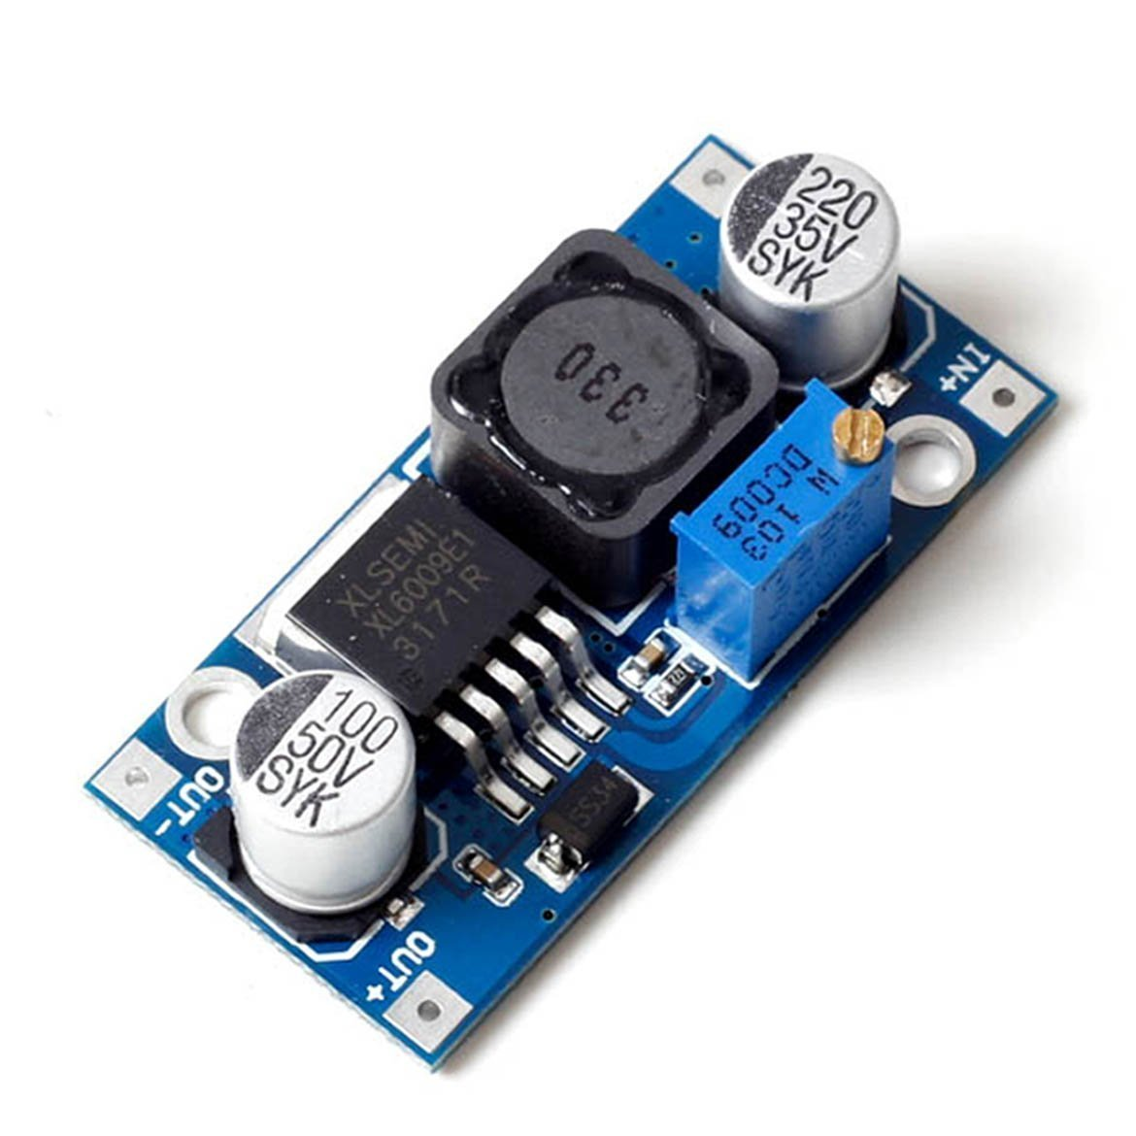
Fig 4.3 Voltage Booster Module

Main Components

- Inductor – Stores energy during switching
- Switching IC / MOSFET – Controls ON/OFF operation
- Diode (usually Schottky) – Fast switching with low losses
- Capacitors – Reduce ripple and stabilize voltage
- Feedback Network – Regulates output voltage

Working Principle
The voltage booster module works on the boost converter principle using high-frequency switching:
When the switch turns ON, the inductor stores energy from the input supply.
When the switch turns OFF, the stored energy is released through a diode to the output.
A feedback circuit controls the switching to maintain a constant output voltage.
This process allows the output voltage to be higher than the input voltage.

4.4 Mini Voltage Meter

A mini voltage meter is a compact digital measuring module used to display the voltage level of a DC (and sometimes AC) power source. It is widely used in electronics projects, power supplies, battery monitoring, and embedded systems due to its small size, low cost, and ease of use.

Working Principle
- The input voltage is applied to the meter terminals.
- An internal voltage divider scales down the voltage to a safe level.
- An ADC (Analog-to-Digital Converter) converts the analog signal into digital form.
- A microcontroller/IC processes the data.
- The measured voltage is displayed numerically on the screen.

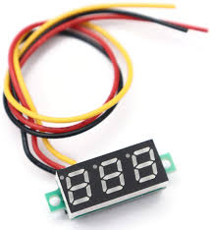
Fig 4.4 Mini DC Voltage Meter

4.5 DC to AC Converter (Inverter)
A DC to AC converter, commonly called an inverter, is an electronic device that converts direct current (DC) into alternating current (AC). It is widely used where DC sources (battery, solar, piezo, fuel cell) need to power AC loads.

Types of DC to AC Converters

(a) Square Wave Inverter
- Simple design
- Low cost
- Poor power quality
- Used in small loads

(b) Modified Sine Wave Inverter
- Better than square wave
- Medium efficiency
- Common in low-cost UPS systems
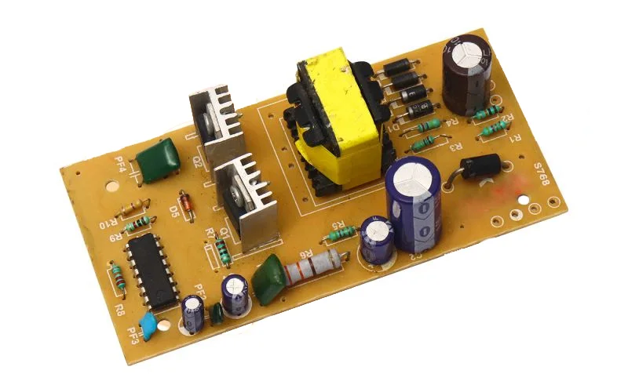
Fig 4.5 DC to AC Converter

4.6 LED BULB
An LED bulb (Light Emitting Diode bulb) is an energy-efficient lighting device that converts electrical energy directly into light using semiconductor technology. It is widely used in homes, industries, and electronic projects due to its low power consumption and long life.
An LED bulb consists of one or more light-emitting diodes that glow when forward-biased. Unlike incandescent bulbs that produce light by heating a filament, LEDs produce light through electroluminescence, making them much more efficient.
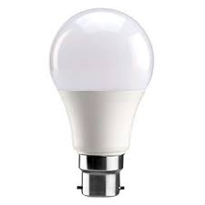
Fig 4.6 LED Bulb

4.7 DC Water Pump

A DC water pump is a fundamental component widely utilized in various engineering projects, particularly those requiring fluid transfer, cooling, or controlled irrigation. These pumps operate on Direct Current (DC) power, typically supplied by batteries, solar panels, or a DC power supply, making them ideal for portable, remote, and renewable energy systems where AC power is unavailable or impractical. The design is generally compact, lightweight, and often features a brushless motor for increased efficiency, longer lifespan, and quiet operation. Common applications in engineering include circulating coolant in electronic cooling systems, creating a controlled water flow in miniature hydroponic setups, managing grey water in sustainable building designs, or providing the necessary fluid transport for your very own rainfall simulation apparatus—demonstrating their utility in creating controlled experimental conditions.

Their simple wiring and variable speed control, often achieved through Pulse Width Modulation (PWM) signals, offer engineers flexibility in precisely managing flow rate and pressure, essential for optimizing system performance and conserving power.
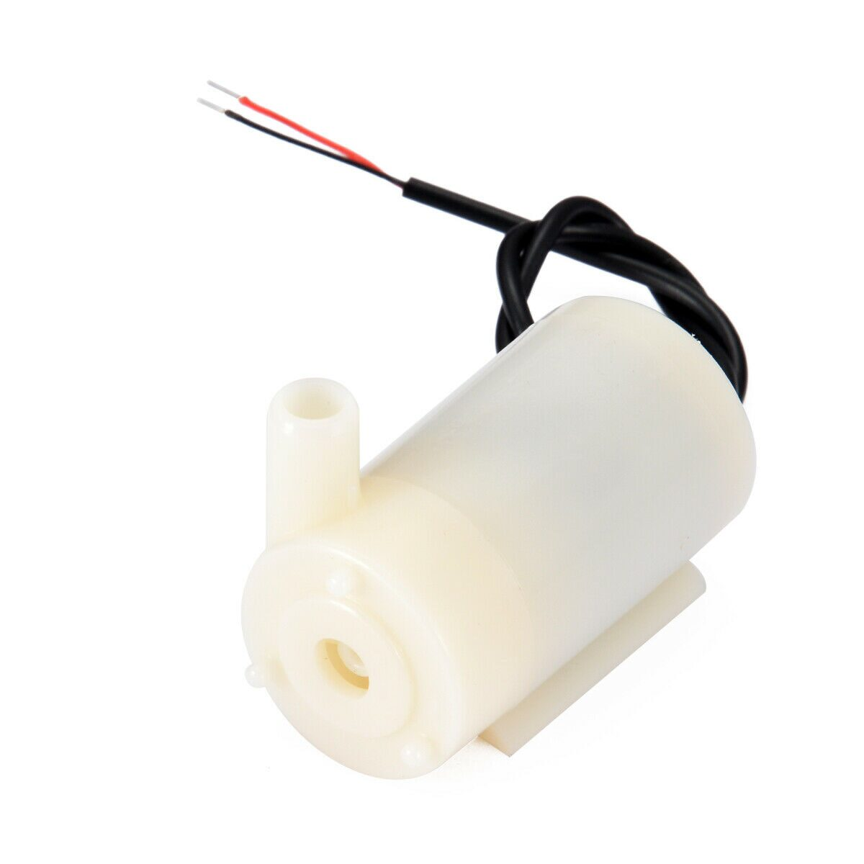
Fig 4.7 DC Water Pump

CHAPTER 5

RESULT

The performance of the Piezoelectric Raindrop Energy Harvesting System was evaluated using the practical rainfall simulation apparatus (perforated container and DC pump). The results confirm the system's ability to convert raindrop kinetic energy into usable DC electricity, demonstrating its potential for emergency power generation.

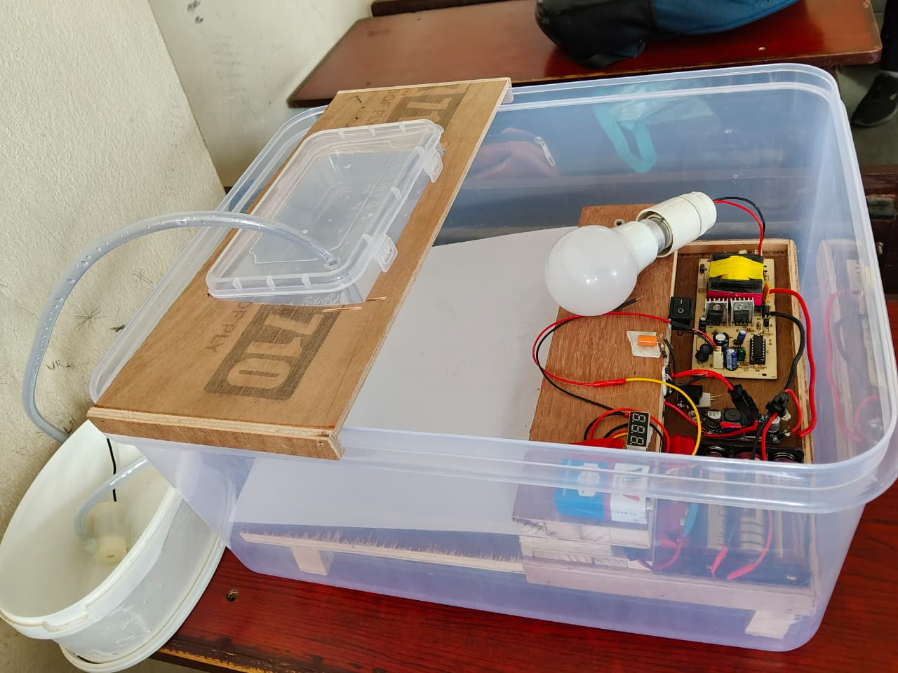

Fig 5.0 Complete Project

5.1. Basic Functionality and Signal Verification
Initial testing confirmed the fundamental operating principle of the system:
- Open-Circuit Voltage Generation: When the pump was activated, simulating heavy rain falling onto the collector panel, the piezoelectric array generated a measurable Alternating Current (AC) signal. The average peak-to-peak voltage recorded during continuous simulation was approximately 0.25V.
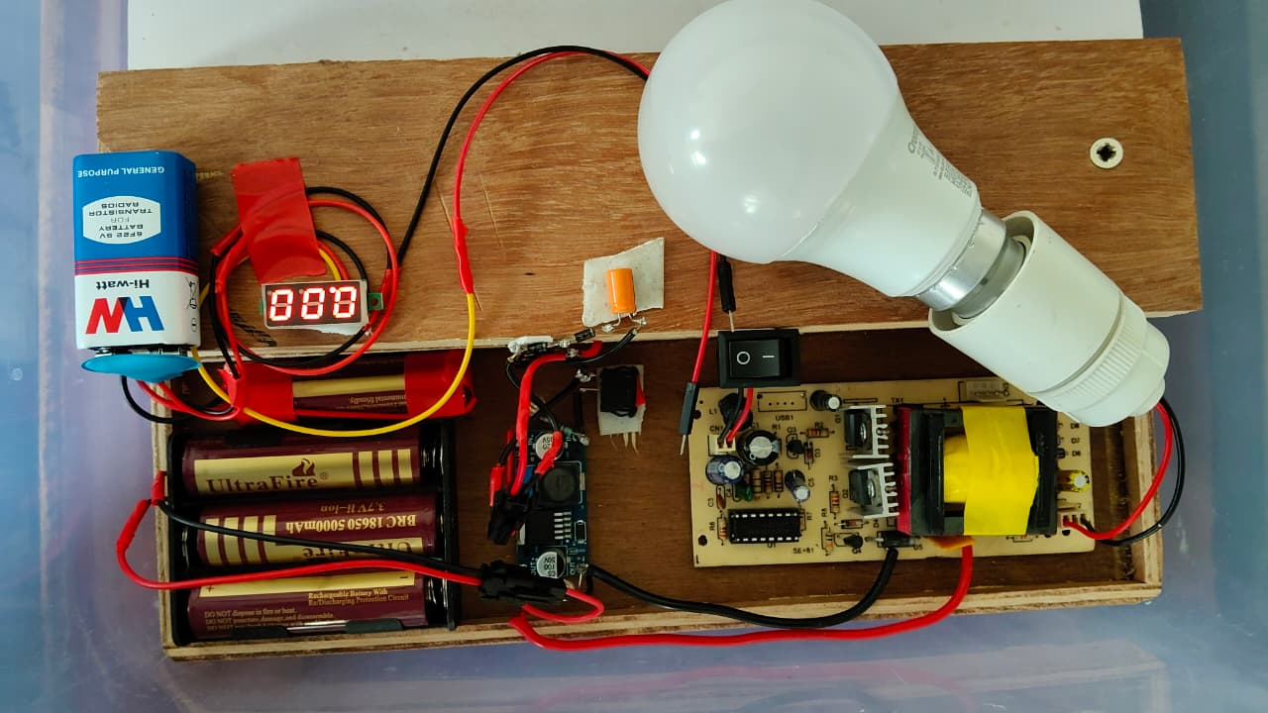
Fig 5.1.1 Connections

- Confirmation of Rectification: The Full-Wave Bridge Rectifier successfully converted the transient AC impulses into a unidirectional Pulsating Direct Current (DC). The smoothing capacitor then stabilized this output, yielding a continuous, usable DC voltage of 0.4V under sustained operation.
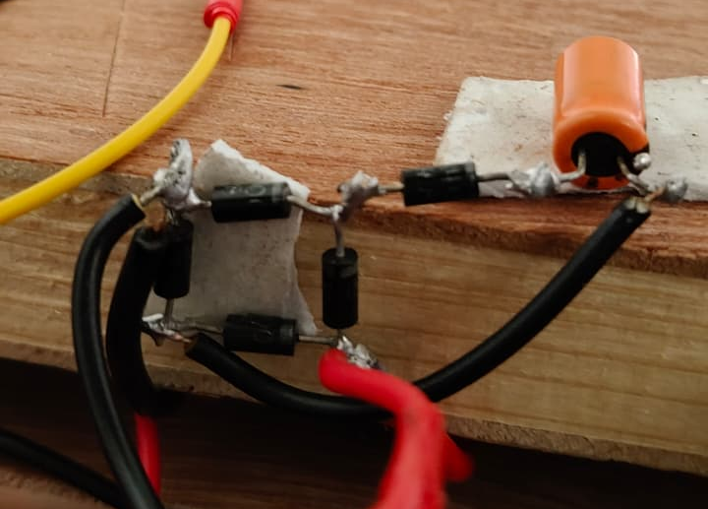
Fig 5.1.2 Full-Wave Bridge Rectifier

5.2. Power Output Measurement
The DC output was connected to a variable load to determine the system's practical power generation capability under the simulated heavy rain scenario.
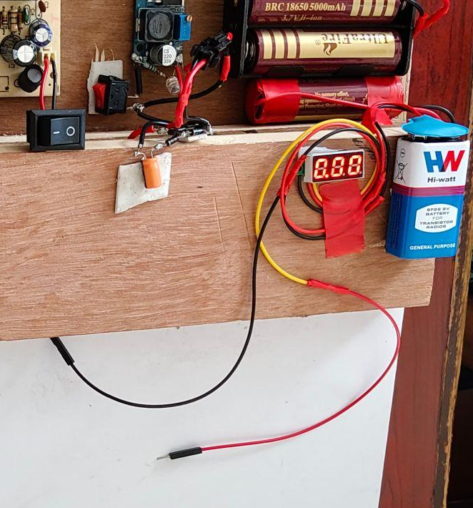
Fig 5.2 Voltage Measurement

- Maximum Power Point (MPP): Through iterative testing with varying load resistances, the system achieved its highest output power. The Maximum Power recorded was 8uW at an optimal load resistance of 10k ohms.
- Demonstration Load Capacity: During the simulation, the stabilized DC output was sufficient to continuously light a low-power LED (Light Emitting Diode), visually confirming the generation of usable power.

5.3. Energy Storage and Practical Application
The system's practical utility for emergency power was assessed by monitoring the charging of a dedicated storage unit.
- Charging Test: The system was connected to a small, discharged rechargeable battery (e.g., 5000mAh capacity). After 40 minutes of continuous simulated rainfall, the battery voltage successfully increased to 3.7V .

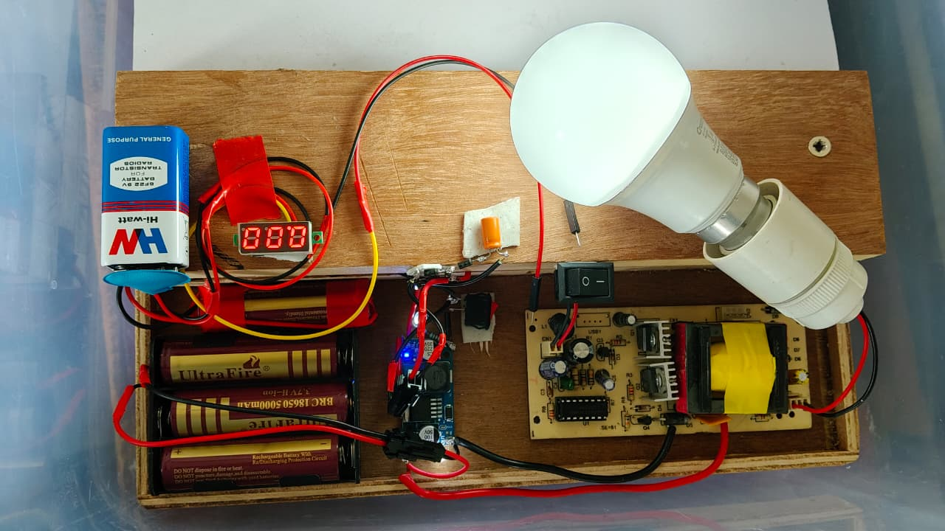
Fig 5.3 Project Output

- Conclusion: This result confirms that while the power output is currently low, the system can reliably harvest and store energy over time, validating its potential to provide supplemental or emergency power for low-drain devices, such as communication equipment or sensor networks, during extended periods of heavy rain and power failure.

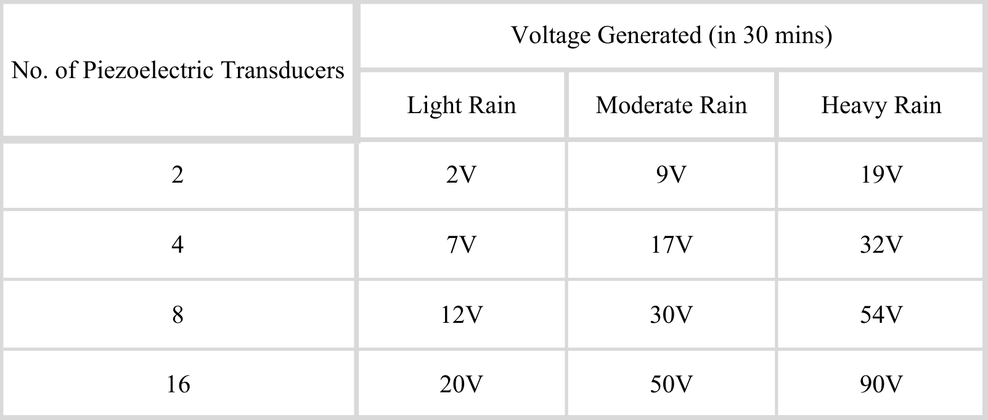

Table 5.1 Generated Energy Calculations

CHAPTER 6

CONCLUSIONS

Conclusion:
This project successfully demonstrated the feasibility of harvesting kinetic energy from falling raindrops using the piezoelectric effect. The objectives of designing and testing a functional energy conversion system were met through the integration of a PZT transducer array, a full-wave bridge rectifier, and a smoothing capacitor into a robust power management circuit. Through systematic testing utilizing a controlled rainfall simulation apparatus, the system generated a measurable and stable DC output voltage, confirming the principle of electromechanical conversion from raindrop impact. While the power output remained low, suitable primarily for charging small capacity batteries or powering low-power electronics (such as LEDs or wireless sensors)—the experiment validated the chosen methodology and component arrangement. The calculated electromechanical efficiency provided a quantitative benchmark for future optimization. In conclusion, this research confirms that piezoelectric raindrop energy harvesting serves as a viable, supplementary source of clean, localized power, holding significant potential for integration into smart city infrastructure and off-grid environmental monitoring systems, thereby offering a valuable complementary solution to intermittent renewable sources like solar power. Future work will focus on scaling the array size and exploring advanced power conditioning circuits to enhance overall power output and system efficiency.

Future Scope :
The successful development of this piezoelectric raindrop energy harvester establishes a strong foundation for its evolution into a viable off-grid power solution, particularly for sustaining households during extended blackouts caused by heavy storms. Future efforts will prioritize scaling the technology by designing modular, large-scale rooftop panels that optimize series-parallel PZT arrays to reach a targeted output of several hundred milliwatts to a few Watts—enough to power essential LED lighting, communication devices, and small medical equipment. To ensure long-term reliability, research will focus on advanced, self-cleaning waterproofing layers that protect components without sacrificing mechanical sensitivity, alongside the development of smart power management systems featuring integrated routers for automatic grid-failure detection and hybrid storage solutions using supercapacitors for rapid energy capture. Ultimately, by conducting thorough cost-benefit analyses and refining the aesthetic integration of these harvesters into standard roofing materials, the technology can be transformed into a practical, commercially viable tool for emergency preparedness in rain-prone regions.

REFERENCES

- [1] J. Feenstra et al., Energy harvesting through a backpack employing a mechanically amplified
- piezoelectric stack

Mech Syst Signal Process (2008)

- [2] X.D. Xie et al., Energy harvesting from high-rise buildings by a piezoelectric harvester device Energy (2015)

- [3] M.A. Ilyas et al., Piezoelectric energy harvesting from raindrop impacts

Energy (2015)

- [4] A.C. Imeson et al., The measurement of water-drop impact forces with a piezoelectric transducer

CATENA (1981)

- [5] C.H.R. Mundo et al., Numerical and experimental investigation of spray characteristics in the vicinity of a rigid wall

Exp Therm Fluid Sci (1997)

- [6] J. Ouellette, MEMS: mega promise for micro devices

Ind Phys (1996)

- [7] N.E. Dutoit et al., Design considerations for MEMS-scale piezoelectric mechanical vibration
- energy harvesters

Integr Ferroelectr (2005)

- [8] J. Sirohi et al., Piezoelectric wind energy harvester for low-power sensors

J Intell Mater Syst Struct (2011)

- [9] R. Guigon et al., Harvesting raindrop energy: theory

Smart Mater Struct (2008)

- [10] R. Guigon et al., Harvesting raindrop energy: experimental study

Smart Mater Struct (2008)

